**P6. Recursion**

**Benjamín Valdez Rodríguez**

**A00822027**

**Código**

//

// main.c

// P6 Recursion

//

// Created by Benjamín Valdez on 2/21/20.

//

#include <stdio.h>

**int** factorial(**int** number) {

**if** (number == 0 || number == 1)

**return** 1;

**else**

**return** (number * factorial(number - 1));

}

**int** fibbonacci(**int** number) {

**if**(number == 0 || number == 1)

**return** number;

**else**

**return** (fibbonacci(number-1) + fibbonacci(number-2));

}

**int** main(**int** argc, **const** **char** * argv[]) {

**int** factorialNumber = 0;

**int** fibonacciNumber = 0;

printf("Enter the number for which you want to find it's factorial: ");

scanf("%d", &factorialNumber);

printf("%d!= %d", factorialNumber, factorial(factorialNumber));

printf("\nFind the fibonacci sequence until n= ");

scanf("%d", &fibonacciNumber);

**for** (**int** i = 0; i < fibonacciNumber; i++) {

printf("%d ", fibbonacci(i));

}

printf("\n");

**return** 0;

}

**Caso de Prueba 1**

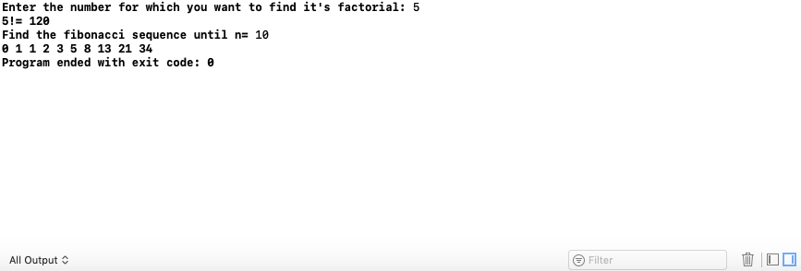

**Caso de Prueba 2**

